ICT-3200, Industrial Visit Report, Part-1
Walton Hi-Tech Industries PLC

Department of Information and Communication Technology
Mawlana Bhashani Science and Technology University

Contents
- Student Information 2
- Introduction 2
- Objectives 2
- Company Overview 2
- Departments Visited 2
- Technologies Observed 3
- ICT Applications 3
- Learning Outcomes 3
- Challenges Observed 3
- Recommendations 4
- Conclusion 4

1. Student Information
Name: Kuldip Saha Mugdha
Student ID: IT22018
Session: 2021–22
Semester: 3rd Year, 2nd Semester
Date of Visit: 21st July, 2026
Submission Date: 8th August, 2026

2. Introduction
Walton Hi-Tech Industries PLC is a well reputed company that manufactures different electronic items and sold it all over the world. As a course ICT-3200 purpose we visited there to get the practical exposure to real world industrial environment.
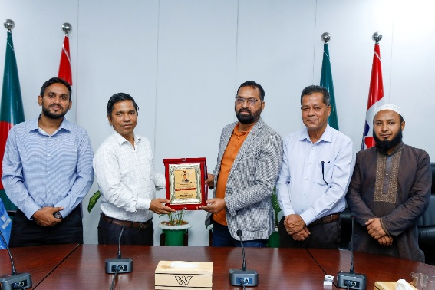
3. Objectives
- To understand modern manufacturing technologies.
- To observe industrial automation systems.
- To learn about quality control processes.
- To study production planning and supply chain management.

4. Company Overview
Walton Hi-Tech Industries PLC in one of the leading manufacturing companies in Bangladesh. It was established in 1977 and has 200+ types of products. It exports over 50+ countries and 70% of the products are refrigerator. This company in 800 acres with 34 buildings and over 30k workers.
Walton is also BSCI and ISO certified.
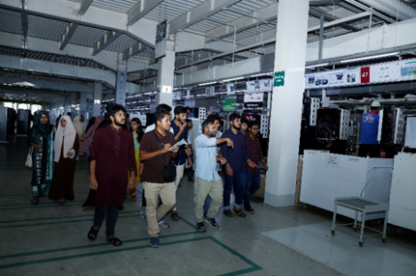
5. Departments Visited
There were lots of department in that industry, but we only visited:
- Refrigerator Manufacturing Section
- Printed Circuit Board (PCB) Manufacturing Section
- ICT Department
- Server Room
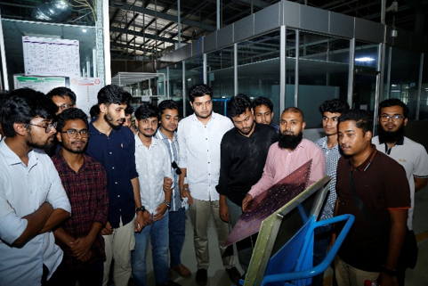
6. Technologies Observed
- Automated manufacturing systems
- Conveyor-based production processes
- Helium leak detection systems
- Screen printing machines
- Advanced testing and inspection systems
- Server-based infrastructure for data management

7. ICT Applications
The key ICT applications are: HRMS, WCRM and EBS. Also we can get more information about it in this portal : www.ictportal.walton.com.
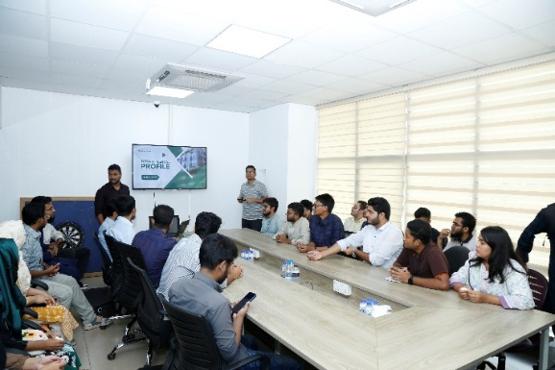
8. Learning Outcomes
- Understanding of real-life manufacturing processes
- Knowledge of industrial automation and ICT integration
- Experience of large-scale production systems
- Insight into professional work environments
- Awareness of how industries maintain quality and efficiency

9. Challenges Observed
- Complex processes that require high-level maintenance and cost
- Dependency on advanced machinery and automation, also need skilled manpower

10. Recommendations
- Further enhancement of automation systems
- Regular training programs for employees
- Strengthening cybersecurity measures

11. Conclusion
This industrial visit to Walton was highly informative to us. Here we get the real-world experience. This experiment will be very efficient for our future.

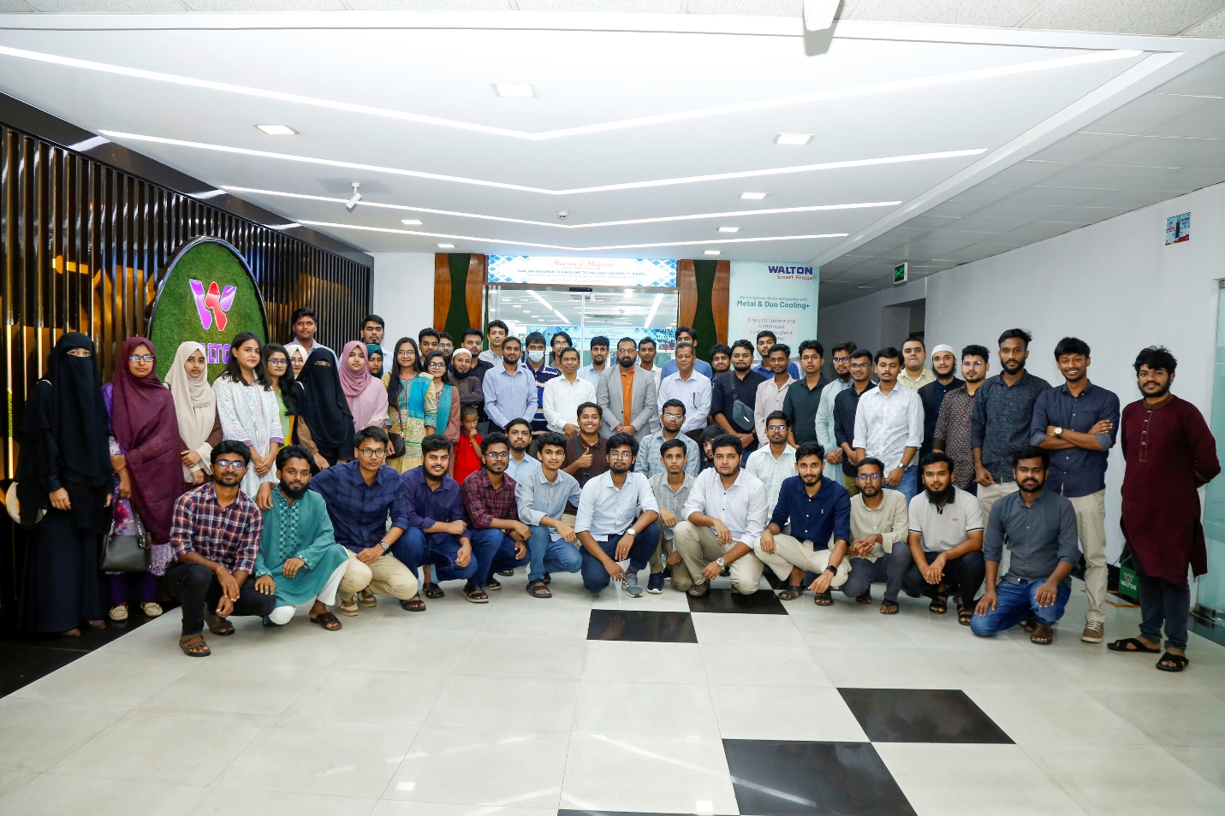
Group Photo of this Industry Visit at Walton Hi-Tech

ICT-3200, Industrial Visit Report, Part-2
Kaliakoir Hi–Tech Park

Department of Information and Communication Technology
Mawlana Bhashani Science and Technology University

Contents
- Student Information 6
- Introduction 6
- Objectives 6
- Organization Overview 6
- Companies Visited 6
- Technologies Observed 7
- ICT Applications 7
- Learning Outcomes 7
- Challenges Observed 7
- Recommendations 8
- Conclusion 8

1. Student Information
Name: Kuldip Saha Mugdha
Student ID: IT22018
Session: 2021–22
Semester: 3rd Year, 2nd Semester
Date of Visit: 21st July 2026
Submission Date: 8th August, 2026

2. Introduction
Kaliakoir Hi-Tech Park is also a well-known ICT Industries in Bangladesh. Our visit aimed to familiarize us with modern technology, ICT infrastructure and industry innovation. Here several gadgets are repaired and upgrade by engineers.

3. Objectives
- To understand the role of Hi-Tech Parks in promoting the ICT industry in Bangladesh.
- To gain knowledge of business automation, optical fiber manufacturing and embedded system applications.
- To explore potential career opportunities in the ICT and telecommunication sectors.

4. Organization Overview
Kaliakoir Hi-Tech Park is one of Bangladesh’s underrated technology parks which is established to accelerate world-class infrastructure and business support service for software companies. The park plays a significant role in attracting investment, generating employment opportunities, promoting local technology industries and contributing to the vision of building a digital Bangladesh.
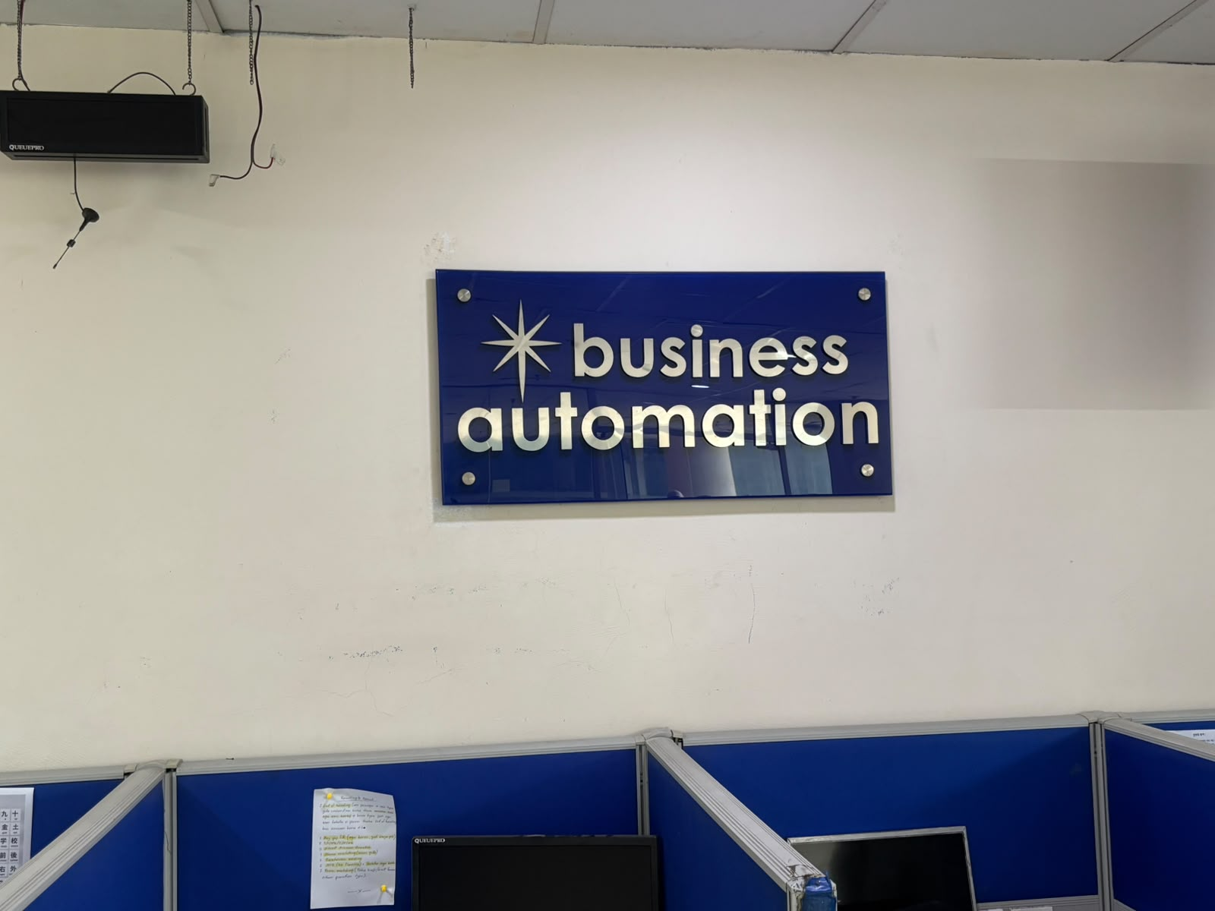

5. Companies Visited
- Business Automation
- NovoCom Limited

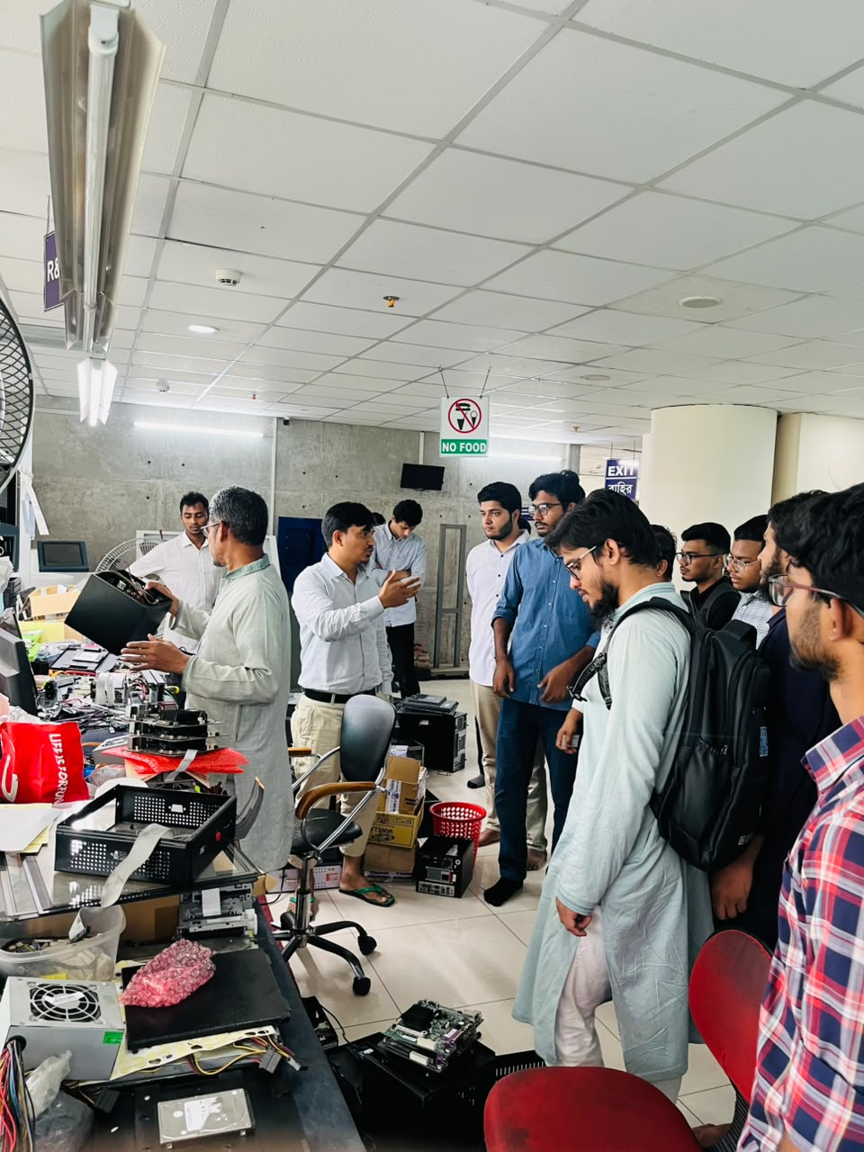
6. Technologies Observed
- Banking automation systems
- Token generator machine development
- Optical fiber manufacturing technologies
- Fiber optic testing and quality assurance techniques
- High-speed networking and communication technologies

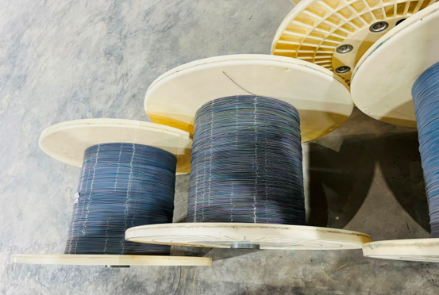
7. ICT Applications
- Banking service automation
- Secure authentication and token generation systems
- Optical fiber communication technology
- High-speed communication infrastructure

8. Learning Outcomes
- Knowledge of banking automation systems and embedded technologies.
- Basic understanding of optical fiber manufacturing and communication systems.
- Exposure to modern industrial ICT infrastructure and professional working environments.
- Increased awareness of career opportunities in software development, embedded systems, networking, and telecommunications.

9. Challenges Observed
- High capital investment required for advanced manufacturing and research facilities.
- Continuous technological advancement requiring regular system upgrades.
- Increasing demand for highly skilled engineers and ICT professionals.
- Maintaining international quality standards and product reliability.
- Ensuring cybersecurity and protection of digital systems against emerging threats.

10. Recommendations
- Strengthen collaboration between universities and technology industries.
- Expand internship, training, and industrial attachment opportunities for students.
- Encourage greater investment in research and innovation.
- Continue upgrading ICT infrastructure to remain globally competitive.
- Organize regular industrial visits to expose students to emerging technologies and industry practices.

11. Conclusion
This industrial visit to Kaliakoir was highly informative to us. Visiting Business Automation and NovoCom Limited enabled us to observe practical applications of business automation, embedded systems and optical fiber manufacturing technologies. Here we get the real-world experience. This experiment will be very efficient for our future.
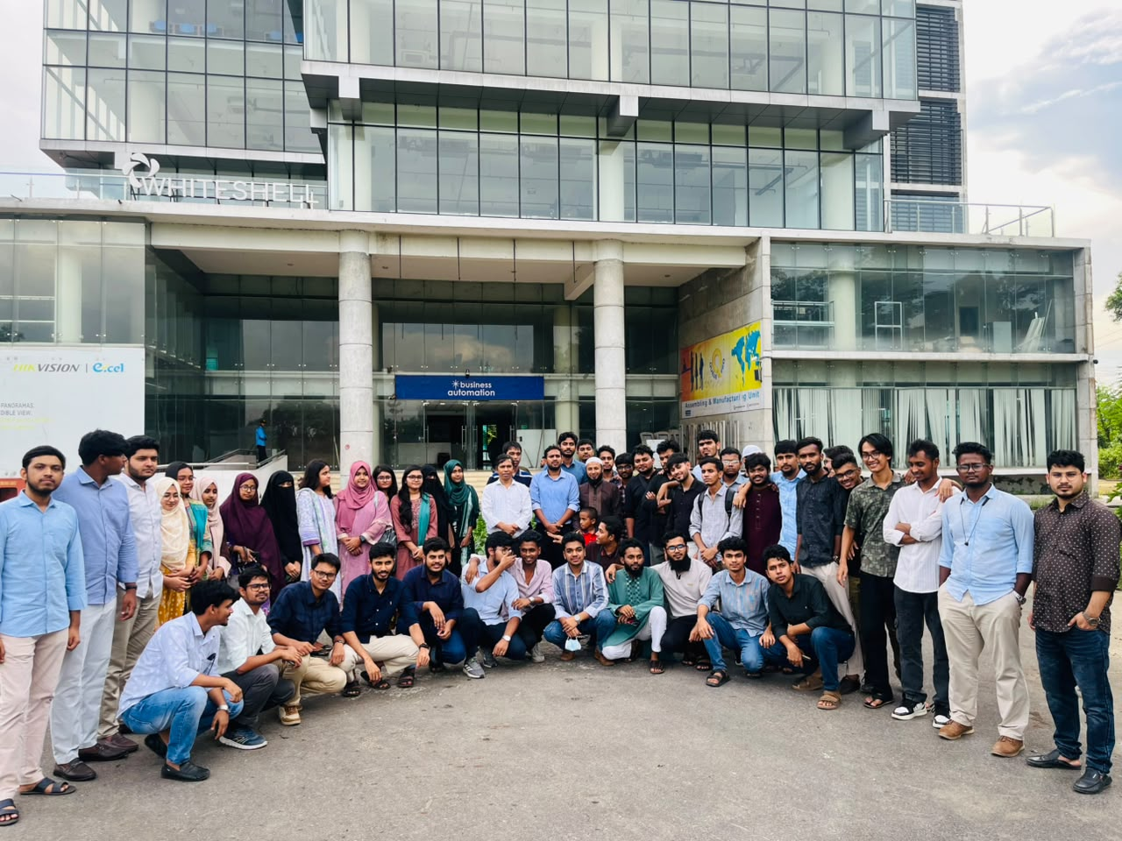
Group Photo In-front Of Business
Automation Company Whitesheel

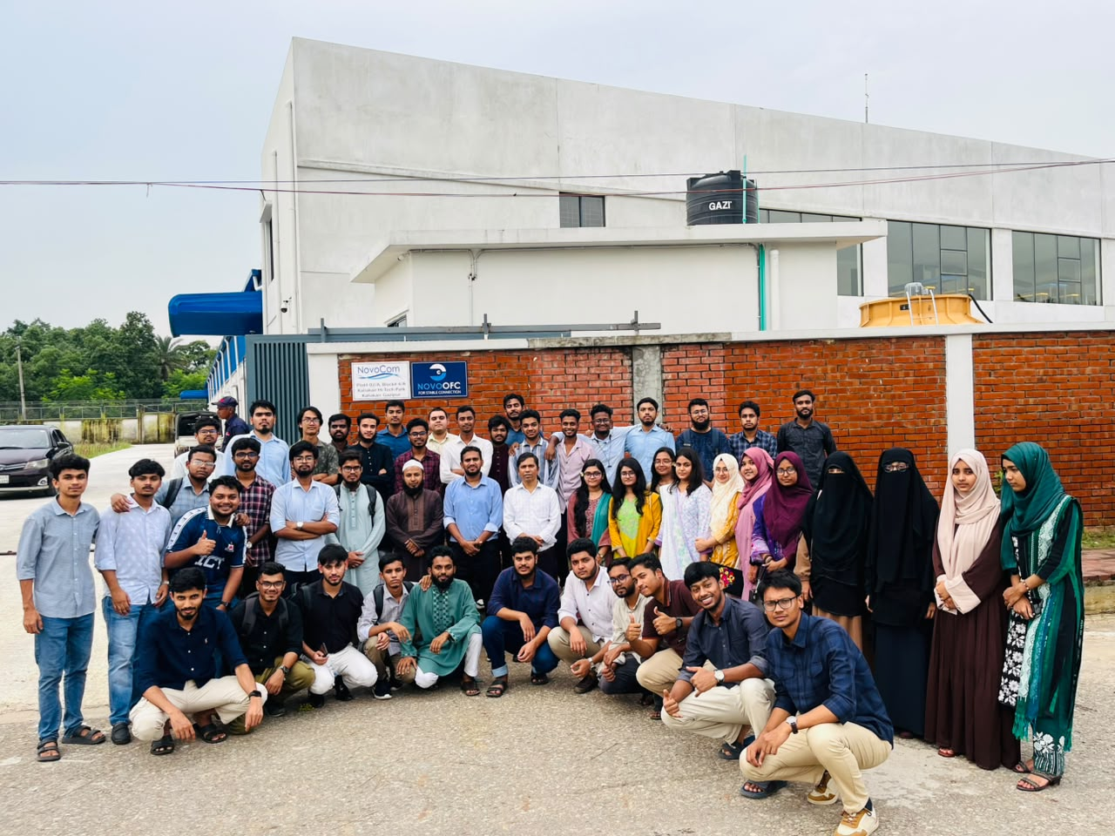

Group Photo In-front
Of Business Automation Company
NovoCom

ICT-3200, Industrial Visit Report, Part-3
Power Transmission Substation Sylhet

Department of Information and Communication Technology
Mawlana Bhashani Science and Technology University

Contents
- Student Information 10
- Introduction 10
- Objectives 10
- Organization Overview 10
- Companies Visited 10
- Technologies Observed 11
- ICT Applications 11
- Learning Outcomes 11
- Challenges Observed 11
- Recommendations 12
- Conclusion 12

1. Student Information
Name: Kuldip Saha Mugdha
Student ID: IT22018
Session: 2021-22
Semester: 3rd year, 2nd semester
Date of Visit: 22nd July, 2026
Submission Date: 8th August, 2026

2. Introduction
Power Transmission Substation Sylhet which plays a vital role in Bangladesh national electricity transmission network. Here the purpose of our visit is to get practical knowledge about high-voltage power transmission, electrical equipment, automation technologies and ICT applications using in modern substations.

3. Objectives
- To understand the structure of Bangladesh's power transmission network.
- To observe the operation of high-voltage transmission equipment.
- To understand the implementation of SCADA for remote monitoring and control.
- To study communication technologies used in power transmission.
- To observe safety measures followed inside a transmission substation.

4. Organization Overview
Power Grid Bangladesh PLC(PGCB) operates this Power Transmission Substation. This station is an important part of the national grid which operates at high-voltage levels (typically 132kV and 230kV) to minimize transmission losses over long distances. It mainly supplies electricity to the northeastern part of Bangladesh.

5. Company visited:
Power Grid Bangladesh PLC, Kumargao, Sylhet.

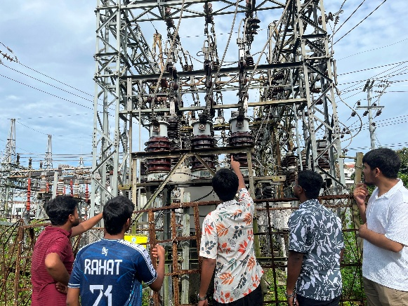
6. Technologies Observed:
- Power Transformers
- Circuit Breakers
- Isolators
- Current Transformers and Potential Transformers
- Capacitor Banks
- Protection Panels

7. ICT Applications
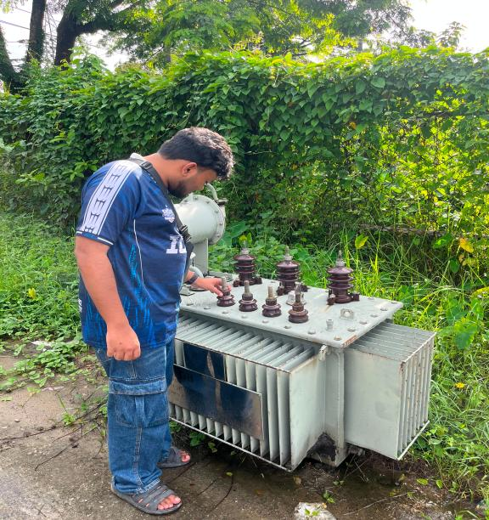
- Industrial Networking
- Cybersecurity
- Data Acquisition Systems
- Asset Management Systems
- AI-Based Fault Detection
- Digital Twin Technology

8. Learning Outcomes
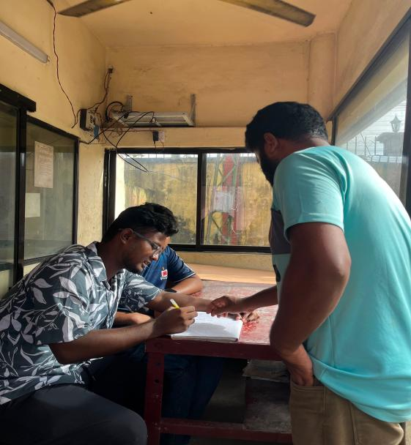
- Understanding of national transmission system
- Knowledge of substation equipment
- Importance of SCADA
- Role of ICT in power systems
- Communication technologies
- Protection techniques
- Safety procedures
- Career opportunities

9. Challenges Observed
- High maintenance cost.
- Need skilled operators
- Cybersecurity threats in digital systems
- Limited hands-on training opportunities for students

13. Recommendations
- More industrial visits
- Practical SCADA demonstrations
- Hands-on communication training
- Cybersecurity awareness
- University–PGCB collaboration
- Smart grid workshops

14. Conclusion
Visit to this substation was highly informative and provided valuable practical knowledge about power transmission, equipment, SCADA, ICT applications and Safety practices which will enhance the power system of Bangladesh.

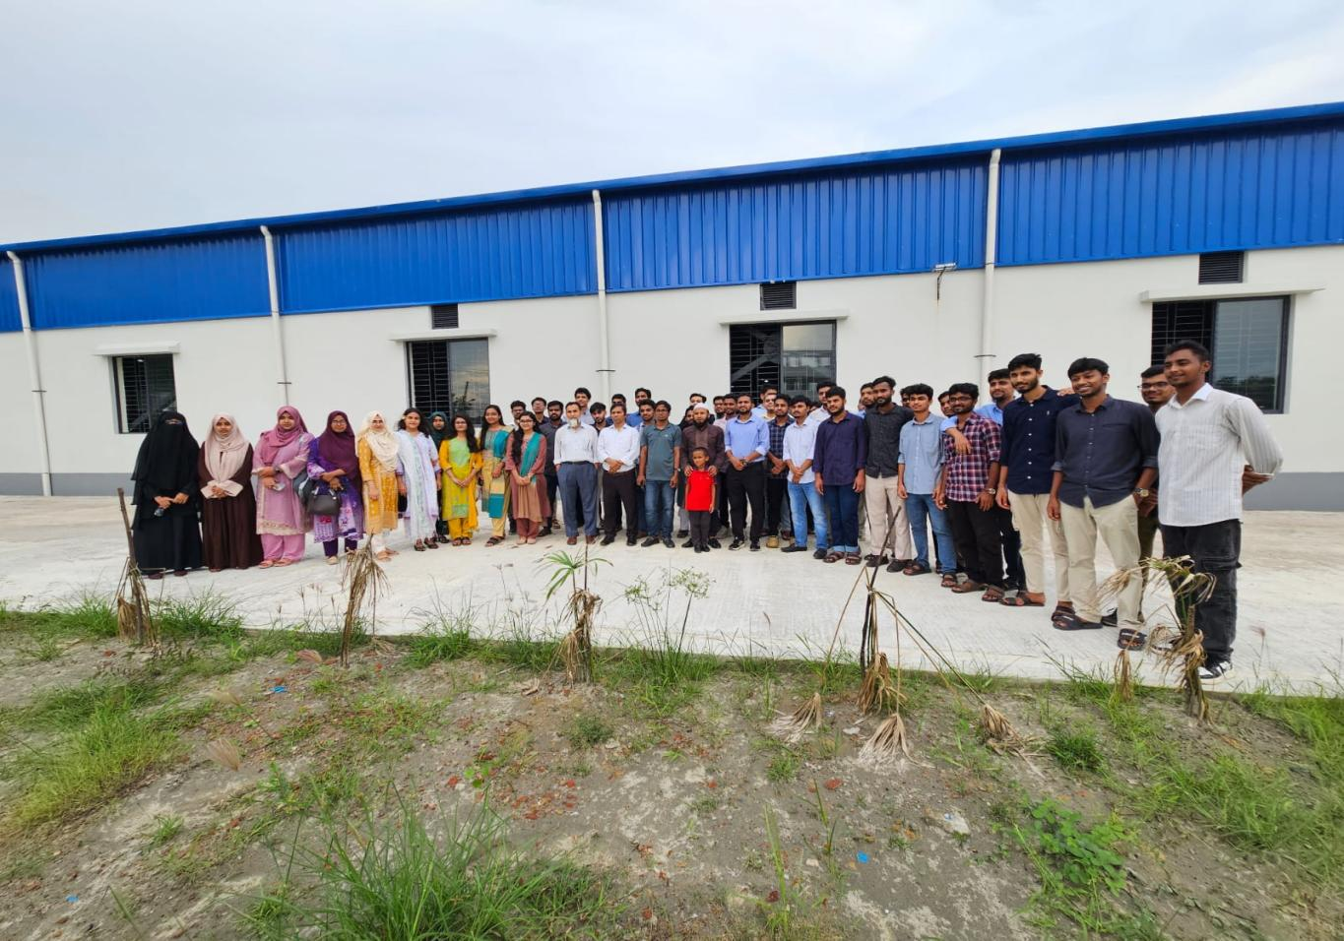
Power Transmission Sub-Station, Sylhet

